

**CarLoanCalculator**

Version 1.1

Prepare By

Komgrit Sangkapradit 5830213015 (Project Management)

Sittinon Srinun 5830213008

Parithat Chokkanapithak 5830213009

Ariya Chomduean 5830213017

Trirawit Chitpong 5830213018

Nareerat Kammorn 5830213025

Tawatchai Thanlaksamee 5830213027

8 November 2016

|  |  |  |  |  |  |  |
| --- | --- | --- | --- | --- | --- | --- |
| Sub – System | Sittinon Srinun    5830213008 | Parithat Chokkanapithak    5830213009 | Ariya Chomdu  ean    5830213017 | Trirawit Chitpong    5830213018 | Nareerat Kammorn    5830213025 | Tawatchai Thanlaksame    5830213027 |
| 1. Customer Management |  |  |  |  |  |  |
| 1.1 Insert a new customer data | / |  |  |  |  |  |
| 1.2 Update an existing customer data |  |  |  | / |  |  |
| 1.3 Delete an customer data |  |  |  |  |  | / |
| 1.4 Display an customer report |  |  |  |  |  | / |
| 1.5 Customer Information Management |  |  |  | / |  |  |
| 1.6 Investigate Information Customer | / |  |  |  |  |  |
| 2. Sales Management |  |  |  |  |  |  |
| 2.1 Add a new purchase order (PO)  (Insert Order) |  |  | / |  |  |  |
| 2.2 Add an order item into PO  (Update Order) |  |  |  |  | / |  |
| 2.3 Delete an order item from PO  (Delete Order) |  |  | / |  |  |  |
| 2.4 Preview a PO before printing it out |  |  |  |  | / |  |
| 2.5 Test order |  | / |  |  |  |  |
| 2.6 Edit order |  | / |  |  |  |  |

**Table of Contents**

1. Revision History 4

1. Use Case Overview 5 - 8

1. System Structure 9

1. Static Structure and Data Analysis 10 - 15

1. System Behaviour Model 17 - 27

1. **Revision History**

|  |  |  |  |
| --- | --- | --- | --- |
| Name | Date | Description | Version |
| Soft En | 8/11/2559 | - | 1.1 |
|  |  |  |  |

Insert a new customer data, Investigate Information Customer

**Mr.Sittinon Srinun | 5830213008**

**2. Use Case Overview**

Use Case Diagram Level 0 : ระบบคำนวณค่างวดสิ้นเชื่อรถยนต์

**Customer**

**Management**

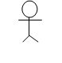

Customer

Management

UC200



ระบบคำนวณค่างวดสินเชื่อรถยนต์

Use Case Diagram Level 1: Customer Management Sub-System (UC200)



**Customer**

**Management**



Insert a new customer data



Investigate Information Customer



Customer

Management Sub

-

System

Use Case Diagram Level 0 : ระบบคำนวณค่างวดสินเชื่อรถยนต์

**Test order and Edit order Parithat Chokkanapithak 5830213009**

1. **Use Case Overview**

Use Case Diagram Level 0 : ระบบคำนวณค่างวดสินเชื่อรถยนต์

ระบบคำนวณค่างวดสินเชื่อรถยนต์

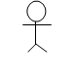

**Sale Management**

Use Case Diagram Level 1: Sale Management Sub-System (UC200)

Sale Management Sub-System

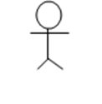

**Sale Management**

**Mr.Thirawit Chitpong | 5830213018**

**Update an existing customer,Customer Information Management**

**2. Use Case Overview**

Use Case Diagram Level 0 : ระบบคำนวณค่างวดสินเชื่อรถยนต์

ระบบคำนวณค่างวดสินเชื่อรถยนต์



**Customer Management**

Use Case Diagram Level 1: Customer Management Sub-System (UC200)

Customer Management Sub-System



**Customer Management**

Delete an customer data, Display an customer report

5830213027 Mr.Tawatchai Thanlaksamee

**2. Use Case Overview**

Use Case Diagram Level 0 : ระบบคำนวณค่างวดสินเชื่อรถยนต์

ระบบคำนวณค่างวดสินเชื่อรถยนต์



**Staff** Management

Use Case Diagram Level 1: Customer Management Sub-System (UC200)

Customer Management Sub-System



**Staff** Management

# 3.System Structure Komgrit Sangkapradit 5830213015

Edit order

Test order

Preview a PO before printing it out

Delete an order item from PO

Add an order item into PO

Add a new purchase order (PO)

Customer Information Management

Investigate Information Customer

Display an customer report

Delete an customer data

Update an existing customer data

Insert a new customer data

Sales Management

Customer Management

Car Loan Calculator System

Insert a new customer data, Investigate Information Customer

**Mr.Sittinon Srinun | 5830213008**

**4. Static Structure and Data Analysis**

**4.1** Model-View-Controller (MVC) Model

Insert a new customer data



Investigate Information Information



Investigate Information

Customer Management Report Screen



Retrieve customer Management From Model



Customer Management

Insert a new customer data

Customer



Investigate Information Information



Investigate Information

Customer Management Report Screen



Retrieve customer Management From Model



Customer Management

**Parithat Chokkanapithak 5830213009**

**Test order and Edit order**

# 4.Static Structure and Data Analysis

This should show the conceptual description of the systematics of the system. Thus, the class diagram is used to describe this static structure of the system. Furthermore, the class diagram is also used for data modelling. Classes in class diagram are classified into 3 types:

## **4.1** Model-View-Controller (MVC) Model

Test order

Sale Management

TestOrderSaleManagementGUI

TestOrderSaleManagementToModel

SaleManagementReportScreen

RetrieveSaleManagementFromModel

Edit order

Sale Management

EditOrderSaleManagementGUI

EditOrderSaleManagementToModel

SaleManagementReportScreen

RetrieveSaleManagementFromModel

## Ariya Chomduean 5830213017

## Model-View-Controller (MVC) Model

Add a new purchase order (PO)

Sale Management

Add PO SaleManagementGUI

Add PO SaleManagementToModel

SaleManagement ReportScreen

RetrieveSaleManagement FromModel

Delete an order item from PO

Delete SaleManagementGUI

Sale Management

Delete SaleManagementToModel

SaleManagement

ReortScreen

RetrieveSaleManagement

FromModel

**Mr.Thirawit Chitpong | 5830213018**

**Update an existing customer,Customer Information Management**

**4. Static Structure and Data Analysis**

**4.1** Model-View-Controller (MVC) Model

Update an existing customer data

Update customer GUI

Customer Management

UpdatecustomerTo model

CustomerManagement

Report Screen

RetrievecustomerManagement

From Model

Customer Information Management

Customer Management

Customer Information Management

Customer Information Management

Customer Management

Report Screen

Retrieve Customer Management From Model

**Model-View-Controller (MVC) Model**

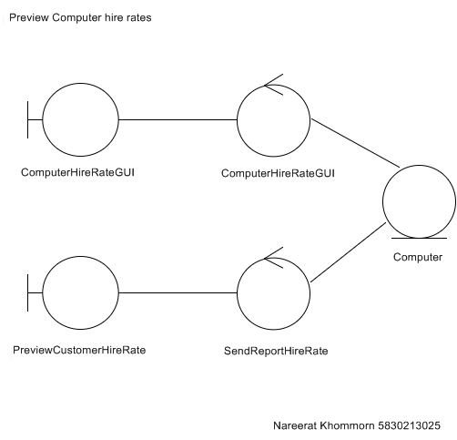

Delete an customer data, Display an customer report

5830213027 Mr.Tawatchai Thanlaksamee

**4. Static Structure and Data Analysis**

**4.1** Model-View-Controller (MVC) Model

Delete an customer data

Staff Management

Delete customer GUI

Delete customer To model

StaffManagement

Report Screen

RetrieveStaffManagement

From Model

Display an customer report

Staff Management

Display an customer report

Display an customer report

StaffManagement

Report Screen

RetrieveStaffManagement FromModel

**4.2 Entity Class Model**

Customer

Customer Id

Customer Name

Customer Address

- Insert Customer

-Update Custome

-Delete Customer

-Display Customer

-CustomerIn formation Management

-Investigate Information Customer

Customer Information Management

Order

Orders

Order Id

Order Date

Price

-Insert Order

-Update Order

-Delete Order

- Test order

- Edit order

**1 order 0…\***

**2 1**

**0..\***

OrderDetails

Order Id

Price

Quantity

Total Price

-Add a new purchase order

-Add an order item into PO

-Delete an order item from PO

**Mr.Sittinon Srinun | 5830213008**

**5. System Behaviour Model**

# Sequence Diagram demonstrating operation “Insert a new customer data”

• This diagram describes the system scenario of “**UC120 : Insert a new customer data**”



**Customer**

**Management**



1:

receive data customer information



2:

Create customer information



3: Check the customer information



status of

4:

information



display status of

5:

information



display status of

6:

Insert customer



Insert customer



Insert customer to



Customer

**Mr.Sittinon Srinun | 5830213008**

# Sequence Diagram demonstrating operation “Investigate Information Customer”

• This diagram describes the system scenario of “**UC150: Investigate Information Customer”**



**Customer**

**Management**



1: Search customer information



2: Select customer information



3: investigate customer information



4: status of investigate customer information



5: display status of investigate customer information



Investigate information



Investigate customer information



Customer



6:

display status of

Customer information

**Parithat Chokkanapithak 5830213009**

**Test order and Edit order**

**5. System Behaviour Model**

**Sequence Diagram demonstrating operation “Test order Sale Management”**

• This diagram describes the system scenario of **“UC250 : Test order Sale Management”**

TestOrderSaleManagementGUI

TestOrderSaleManagementToModel

Sale Management

**Sale Management**

**Service**

2: set the test sale marketing

1: Test order of sale marketing

3: test sale marketing

4: status of test

operation

5: display status of

test operation

6: display status of

test operation

**Parithat Chokkanapithak 5830213009**

**Test order and Edit order**

## **Sequence Diagram demonstrating operation “Edit order Sale Marketing”**

* This diagram describes the system scenario of “**UC260: Edit order Sale Marketing”**

EditOrderSaleManagementGUI

Sale Management

EditOrderSaleManagementToModel

**Sale Management**

**Service**

2: set the edit sale marketing

1: Edit order of sale marketing

3: edit sale marketing

4: status of edit

operation

5: display status of

edit operation

6: display status of

edit operation

**Ariya Chomduean 5830213017**

**Sequence Diagram demonstrating operation “: Add a new purchase order (PO)Sale Management”**

• This diagram describes the system scenario of **“UC250 : Add a new purchase order (PO)Management”**

Sale Management

Add PO SaleManagementToModel

Add PO SaleManagementGUI

**Sale Management**

**Service**

1: Add a new purchase order of sale marketing

2: set the new purchase order sale marketing

3: new purchase order sale marketing

4: status of new purchase order operation

5: display status of new purchase order operation

6: display status of new purchase order operation

**Ariya Chomduean 5830213017**

## **Sequence Diagram demonstrating operation “Delete an order item from PO Sale Marketing”**

* This diagram describes the system scenario of “**UC260: Delete an order item from PO Sale Marketing”**

Delete order SaleManagementToModel

Sale Management

Delete order SaleManagementGUI

**Sale Management**

**Service**

2: set the Delete order

sale marketing

1: Delete order of sale marketing

5: display status of

Delete order operation

6: display status of Delete order operation

3: Delete order sale marketing

4: status of Delete order operation

**Mr.Thirawit Chitpong | 5830213018**

**Update an existing customer,Customer Information Management**

## **5. System Behaviour Model**

**Sequence Diagram demonstrating operation “Update an existing customer”**

• This diagram describes the system scenario of **“UC120 : Update an customer ”**

Customer Management

Update customer GUI

**Customer Management**

**Service**

Update customer

To model

1: receive new customer

information

2: check information for edit

3 insert update

6: display status of

Update customer

4: status of update information

5: display status of

update information

**Mr.Thirawit Chitpong | 5830213018**

**Update an existing customer,Customer Information Management**

## **Sequence Diagram demonstrating operation “Customer Information Management”**

* This diagram describes the system scenario of “**UC150: Customer Information Management”**

Customer Information Management

Customer Management

**Customer Management**

**Service**

Customer Information Management

2: Check information on

be correct

1: Select type of information

3: send for edit or update information

5: display status of

information management

4: status of information

management

6: display status of

information management

## **5. System Behaviour Model**

**Sequence Diagram**

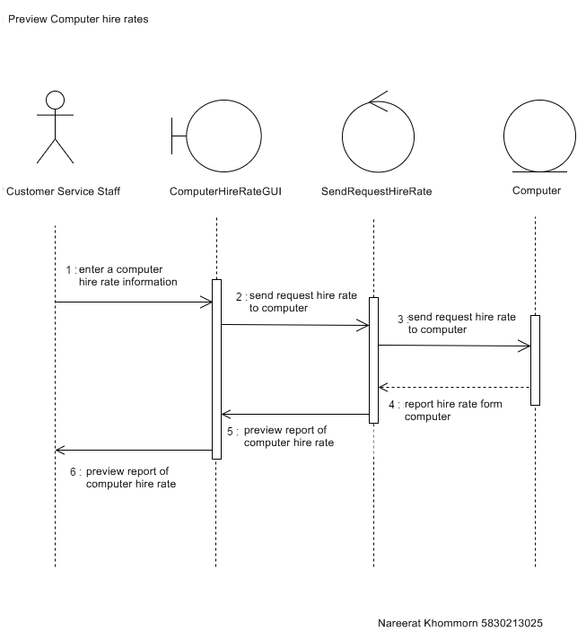

Delete an customer data, Display an customer report

5830213027 Mr.Tawatchai Thanlaksamee

## **5. System Behaviour Model**

**Sequence Diagram demonstrating operation “Update an existing customer”**

• This diagram describes the system scenario of **“UC150 : Delete an customer data ”**

Delete an customer GUI

Customer Management

Update customer

To model

**Staff Management**

1: receive new customer

information

2: set the test sale marketing

3 insert update

6: display status of

Update customer

4: status of update information

5: display status of

update information

## **Sequence Diagram demonstrating operation “Customer Information Management”**

* This diagram describes the system scenario of “**UC150: Customer Information Management”**

Customer Management

Customer Information Management

Customer Information Management

**Customer Management**

**Service**

2: Check information on

be correct

1: Select type of information

3: send for edit or update information

5: display status of

information management

4: status of information

management

6: display status of

information management